**Two Pointers Pattern**

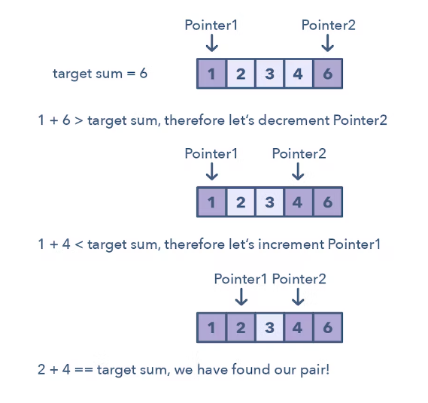

**Ways to Identify the pattern:**

* It will feature problems where you deal with sorted arrays (or Linked Lists) and need to find a set of elements that fulfill certain constraints
* The set of elements in the array is a pair, a triplet, or even a subarray

**Common problems you use the sliding window pattern with:**

* Squaring a sorted array (easy)
* Triplets that sum to zero (medium)
* Comparing strings that contain backspaces (medium)

**Broad Categories:**

* First pointer at start moving up, second pointer at end moving down
* Both the pointer in the middle moving in two opposite directions
* One pointer scanning the list, another pointer fixed, moving on certain criteria
* Three pointers, first pointer scanning the list, second pointer moving up and third pointer moving down

**Strategies to Solve the Problem:**

* Identify the way in which the pointers will traverse